What is the Optimal Amount of potassium hydroxide to use in order to achieve maximum change in enthalpy for the chemiluminescent reaction of luminol?

Leo Chai

White Oaks Secondary School

# Introduction

I went to my first concert when I was in grade 7, and I was shocked by the energy generated by the fans. That was also the first time when I was introduced to glowsticks, which the crowd used to show their support for the performer. I have attended many more concerts since, and I noticed that other people would often bring many different variants of glowsticks: some glowed for a longer time period with dimmer brightness while others provided a short burst of intense luminescence.

I have since been wondering how the glowstick producers controlled the enthalpy of the glowsticks. After doing some research online, I have found that temperature changes the reaction rate of the chemicals inside a glowstick; as the temperature increase, the reaction rate also increases. (Shinde & Narwade, 2014) This is because an increase in temperature causes the molecules in the glowstick to move faster, which causes them to bump into each other more often. Thus, a higher temperature causes a higher reaction rate. (Gross, 1968)

However, the audience of the concert all held the glow sticks in their hands. This means that all the glowsticks were in an environment of the same temperature, and thus the manufacturers could not have controlled the reaction speed using temperature.

After looking up experiments involving the chemiluminescence reaction in glow sticks, I have found a video showing that adding soap to glowstick reactions increases the brightness of the light produced. (The King of random, 2018) In this video, the producers have added soap in an attempt to mix hot water with the chemicals inside a glow stick. However, while doing so, they realized that adding soap makes the glow stick solution glow brighter than before. This leads me to become suspicious that the chemiluminescent reaction of glow sticks is pH-dependent, as washing soap has the chemical property of being alkaline (basic).

To test my suspicion, I started researching the relationship between the pH of the solution and its reaction rate. I found out that most chemiluminescent reactions inside glow sticks are pH-dependent. (Welsh, 2011)

Glow sticks achieve their luminescence through the reaction of diphenyl oxalate, hydrogen peroxide, a base catalyst and a dye. The diphenyl oxalate reacts with the hydrogen peroxide to produce phenol and 1,2-dioxetanedione. The 1,2-dioxetanedione splits into 2 carbon dioxide, and releases energy. This energy is consumed by the dye to produce light of different wavelengths depending on the dye. (Clark, 2000)

The alkaline environment is important because it performs a deprotonation reaction with the hydrogen peroxide. Deprotonation reactions remove a proton from lewis acid. In this case, a proton is so that from the hydrogen peroxide in the form of a hydrogen atom. This reaction creates strong dipoles, allowing the OH to react to the diphenyl oxalate.

**Figure 1.** Chemiluminescent reaction of diphenyl oxalate.

deprotonation

+

+

2

+

However, the reaction will also be quickly exhausted if the solution was overly alkaline. This is because that the hydroxide anion would react with the hydrogen peroxide to form oxygen gas and water, making the diphenyl oxalate unable to react.

I have decided to test out the extent of the effect of pH on the brightness of the chemiluminescence reaction. Because of safety regulations, I am not allowed to handle diphenyl oxalate, so I will be using luminol as an alternative. Luminol has similar chemical properties and reacts similarly to diphenyl oxalate and the dye within this reaction. I will be changing the amount of potassium hydroxide to control how alkaline the solution is. Since the reaction does not emit energy as heat but as light instead, (Kuntzleman, Roher, & Schultz, 2012) I cannot measure temperature change to determine the reaction rate. Since light is emitted instead, I will be measuring the intensity of the light at a fixed distance from the reaction, and attempt to calculate the energy emitted as light.

## Reaction

Here, I will give more detail of the specific chemiluminescence reaction of luminol, and explain its relationships with the pH.

In the first step of the reaction, the luminol reacts with an OH ion. The OH ion mainly comes from the base dissolved in water, but small amounts may also come from the decomposition of hydrogen peroxide. Since the OH ion is negatively charged, it acts as a nucleophile and takes away the single hydrogen attached to the nitrogen in the luminol.

δ+

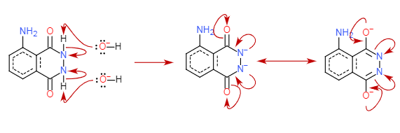

**Figure 2.** Luminol reacting with hydroxyl ion to form keto-enol tautomer.

A keto-enol tautomer is formed as a result of this reaction, where the chemical switches between the form of a ketone/aldehyde or an alcohol to achieve equilibrium.

The enol form of this chemical is unstable as the Oxygens are not attached to hydrogens and is negatively charged. This allows them to react to O2 gas that comes from the decomposition of Hydrogen peroxide

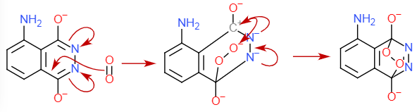

**Figure 3.** Enol form of tautomer reacting with oxygen to form dianion

As the chemical is switching from its enol state to keto state, two pairs of electrons from the double bonds between the carbon and nitrogen transfer to the nitrogens. This creates a temporary positive dipole at the two carbon before the oxygen uses its electron to create a double bond. In this instance, one of the carbon reacts with the electron-rich double bond between the oxygen. It takes a pair of electrons from the double bond, making the other oxygen electron deficient. Meanwhile, the two negatively charged nitrogen repels each other. Since there is a positively charged carbon, one of the negatively charged electron is given to the carbon atom while the other one forms a double bond between the two nitrogen. The positively charged oxygen then acts as an electrophile, and bond with the free electrons on the carbon.

Normal decomposition of Hydrogen peroxide is not sufficient to produce a visible glow since it decomposes very slowly. A reaction between the base and the potassium ferricyanide speeds up the production of oxygen. The hydroxyl separates from its ion as the potassium reacts with the potassium ferrocyanide. The hydroxyl ion then takes a hydrogen atom away from the hydrogen peroxide. The hydrogen dioxide is very unstable, and two of them combine together to form oxygen and hydrogen gas.

When there is more hydroxyl ion in the solution, the hydrogen dioxide will react with another hydroxyl ion instead of hydrogen dioxide. The result of this is that instead of forming hydrogen gas, it forms another water molecule.

The cyclic peroxide produced is even more unstable because of the negative charges on the oxygen atom, and since it cannot form the resonant keno-enol states. The ionized oxygen has a full outer shell of electrons, making it so that they cannot simply leave the molecule to form oxygen gas with double bonds. It instead repels the nitrogen from the carbon. As the nitrogen is repelled further, the bond between the carbon and the nitrogen becomes weaker. Enthalpy causes the carbon to have a stronger attraction to electrons. The pair of electrons on the oxygen bonds with the carbon due to this attraction. This oversaturates the carbon’s outer electron shell, which causes the nitrogen to be repelled out of the molecule to form nitrogen gas.

One of the nitrogens takes away the electrons that they have used to bond with carbon in order to form a triple bond, leaving the other carbon with an extra pair of electrons. Since oxygen has higher negativity than carbon, the pair of electrons move toward the other oxygen atom that is single bonded to the carbon. As the electron is attracted toward the oxygen, it repels the pair of bonding electrons between the two oxygen. This eventually causes the bond between the oxygen to break, and ionizing both of the oxygens single bonded to the carbon atoms.

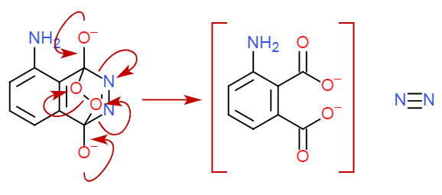

*

+

**Figure 4.** Dianion decomposes to form 3-aminophthalate* and nitrogen gas

The breaking of bonds causes the dianion to exist in an excited state: the oxygen exists in the triple-state with two electrons without an electron pair of the opposite spin. When the molecule decay to its ground state, it releases a photon in the process. This light is what is the blue light that is present during the chemiluminescence reaction of luminol.

The excited dianion is called 3-aminophthalate*, and it can be bonded with water molecules since it is dissolved in water. This creates two different versions of the chemical. The different structure causes its electrons to be experiencing different amounts of forces, which causes them to emit photons of different wavelengths.

## Enthalpy

The chemiluminescent reaction of luminol releases a set amount of photons (energy) for each mole of reaction. Since the reaction only releases energy in the form of light, the change in enthalpy can be used to represent the amount of light emitted from the reaction.

Luminol stores potential energy inside the chemical, and some of this energy is released during the reaction as light. Therefore, by figuring out the change in enthalpy per mole for this reaction, I can figure out the amount of energy emitted as light per mole of molecules.

Since each luminol’s chemiluminescent reaction produces one photon, the molar change in enthalpy can be calculated through the exploration of the energy carried away by the released proton. However, since the 3-aminophthalate* exists in two forms, the reaction emits two different wavelengths of photons: 424 nm for 3-aminophthalate* not bonded with water and 485 nm for 3-aminophthalate* that are bonded with water. (Felming, 2002)

(PV EDUCATION, 2016)

Since the two forms of 3-aminophthalate* exist in different concentrations, the total change in enthalpy will depend on the concentration (molar fraction) of its two forms in each solution.

**Note:** ΔH represents the change in Enthalpy; NA is Avogadro's constant; h is Planck's constant; c is the speed of light; λ represents wavelength; x is the molar fraction of 3-aminophthalate*

## Research Question

What is the optimal amount (g) of potassium hydroxide (KOH) to have relative to the amount (g) of luminol (C8H7N3O2) when excess potassium ferricyanide (K3[Fe(CN)6]) is present in the solution to achieve the maximum change in enthalpy for the occurring chemiluminescent reaction?

## Hypothesis

When the solution containing luminol is acidic or neutral, the change in enthalpy will be zero as there are no hydroxide anions to catalyze the reaction. As the amount of hydroxyl ion in the solution increases, the change in enthalpy will increases because there is more hydroxyl ion to assist the reaction. However, as the amount of hydroxyl ion exceeds the amount of hydrogen peroxide, the change in enthalpy will decrease logarithmically. It will start decreasing because water will be formed from the catalyst reaction instead of hydrogen gas, causing more 3-aminophthalate* to bond with water. This makes it so that they release a photon with greater wavelength but less energy. The change in enthalpy decreases logarithmically because it approaches the change in enthalpy with all the photons being bonded with water. However, it will never reach there as there will always be ones that are bonded with water.

# Methodology

Table 1

## Variables

|  |  |  |  |
| --- | --- | --- | --- |
| Variable type | Variable name | Unit | Explanation |
| Independent Variable | The amount of potassium hydroxide | g | I have mixed 0, 1, 2, 3, 4, and 5 grams of potassium hydroxide in the solution. I chose these values because the potassium hydroxide comes in pallets, and testing with small amounts will create a large percentage uncertainty. |
| Dependent Variable | The illuminance of the chemical | lux | The illuminance is measured with a lux meter that is connected with my phone through Bluetooth. The lux meter is fixed on a mini tripod. |
| Controlled variable | Temperature | 23.6 °C | The temperature affects the reaction rate of luminol. Higher temperature makes luminol react faster and thus glow brighter. Dissolving potassium hydroxide is also exothermic and produces heat. The temperature is controlled by creating a heat sink to cool the solution down. The heat sink is created by placing the beaker with the solution in another larger beaker filled with water. |
| Controlled variable | Amount of luminol, hydrogen peroxide, potassium ferricyanide and water | 0.1 g  25 ml  1 g  50 ml | The amount of other chemicals involved in the reaction directly contributes to the brightness of the light emitted. My hypothesis assumes that potassium hydroxide is the limiting reagent. To make sure this is the case, I have used an excess of other materials compared to my research results of other people performing similar reactions with luminol. |
| Controlled variable | Mixing time of solution | 3.5 s | The luminol chemiluminescent reaction happens very quickly. To reduce uncertainty, I mix the two liquids through a rubber tubing to extend their reaction time. The rubber tubing limits the speed of adding the two chemicals, and the reaction time was measured to be 3.5 seconds |
| Controlled variable | Background brightness | 0 lux | By having the background brightness low, I can turn the sensitivity up on my lux meter for more accurate measurements. To ensure that the reaction happens in a dark environment, I used a box to block the surrounding light with only the rubber tubing passing the chemicals inside to mix. |
| Controlled variable | Distance between reaction and measurement device | 3 cm | The distance between the luminescent source and my lux meter plays a role in the calculations for determining the change in enthalpy from the illuminance of the chemical. Since the lux meter is set on a tripod, I placed the tripod 3 cm from the beaker containing the chemicals. Having this distance set at constant helps make my calculations later easier. |

## Materials

* rubber tubing – 40cm
* funnel - 1
* ring clamp - 1
* retort stand - 1
* box - 1
* stirring rod - 1
* weighing paper – 3
* lux meter – 1 (± 0.1 lx)
* luminol – 2.5g
* potassium hydroxide – 60g
* distilled water – 1.25dm3
* 3% hydrogen peroxide – 625cm3
* potassium ferricyanide – 25g
* electronic scale – 1 (± 0.1 g)
* graduated cylinder (100 cm3) – 2 (± 1 cm3)
* beaker (250 cm3) - 2
* beaker (500 cm3) – 1

## Safety Precautions

The potassium hydroxide is a strong base, and is very corrosive after dissolved in water. This lab works with very alkaline solutions (pH 12), thus it is important to put on gloves and goggles to prevent damage to the skin. If the alkaline chemical is spilled, use alkaline neutralizer from the special spill kit to clean up.

Initially planned to test how luminol will react in an acidic environment adding using sulfuric acid in the solution. However, after doing research, I realized that hydrogen peroxide will react with sulfuric acid to form a very dangerous solution that is called the “piranha solution”. (University of Pennsylvania, 2010) I have since abandoned the idea of testing in an acidic environment and I will only be using an alkaline solution for safety

Directly pouring the solution after reaction down the drain will pollute the environment since it is a strongly alkaline solution. The waste therefore must be dumped into the alkaline chemical waste bin for treatment.

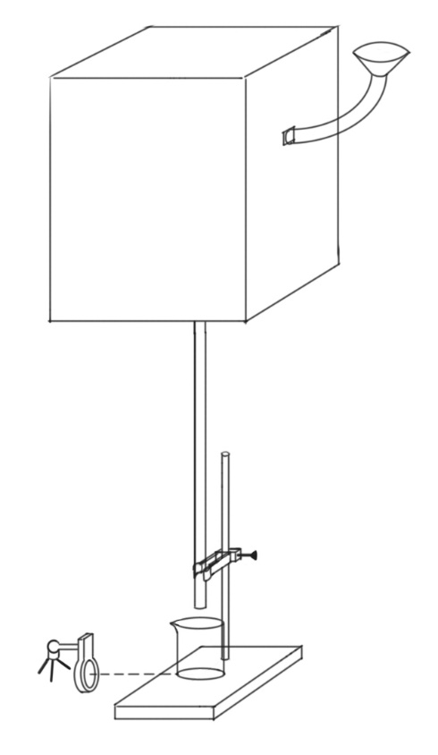

Box (reduce brightness)

Funnel

rubber tubing

retort stand

ring clamp

solution 1

3cm

lux meter

tripod

**Figure 5.** Diagram of the apparatus setup

Luminol and potassium ferricyanide have complex chemical structures, and cannot be easily decomposed. I have cut down the scale of the entire reaction by half to decrease waste. This reduces damage to the environment.

## Method

1. Gloves, Goggles and an apron was put on for safety.
2. Apparatus was set up according to the diagram (Figure 5)
3. Labeled the 3 weighing paper with “luminol”, “potassium hydroxide” and “potassium ferricyanide”
4. Label the 250 ml beakers and the graduated cylinder “solution 1” and “solution 2”
5. Measured 0.1 gram of luminol and 0 grams of potassium hydroxide with the electric scale and their weighing paper.
6. Measured 50 ml of distilled water using the solution 1 graduated cylinder.
7. Mixed the luminol, potassium hydroxide and the distilled water in solution 1 beaker using a stirring rod to form solution 1.
8. Filled the 500 ml beaker with about 200 ml of tap water.
9. Solution 1 beaker was set aside in the 500ml beaker to cool.
10. Measured 1 g of potassium ferricyanide with the electric scale and its weighing paper.
11. Measured 50 ml of hydrogen peroxide and 50 ml of distilled water with solution 2 graduated cylinder.
12. Mixed the potassium ferricyanide, hydrogen peroxide and distilled water in solution 2 beaker using a stirring rod to form solution 2.
13. Solution 1 was placed under the rubber tubing inside the box, 3 cm away from the lux meter.
14. Lux meter started recording values.
15. Solution 2 was poured into the funnel quickly. (to ensure uniform flow rate)
16. The recording on the lux meter was saved after the reaction finished. (indicated with lux meter reading dropping to 0)
17. Solution was dumped into alkaline waste
18. The two beakers were rinsed with tap water.
19. Repeat steps 4 – 17 5 more times but with 1, 2, 3, 4 and 5 g of potassium hydroxide.

# Analysis

Table 2

## Illuminance (lux) of the reaction luminol when different amounts of KOH are present in the solution (0, 1, 2, 3, 4, 5 grams)

|  |  |  |  |  |  |  |  |
| --- | --- | --- | --- | --- | --- | --- | --- |
| Amount of KOH (g) | Trial | 1st recording (lux) | 2nd recording (lux) | 3rd recording (lux) | 4th recording (lux) | Uncertainty (lux) | |
| 0 | 1 | 0.0 | 0.0 | 0.0 | 0.0 | ± 0.1 |
| 2 | 0.0 | 0.0 | 0.0 | 0.0 | ± 0.1 |
| 3 | 0.0 | 0.0 | 0.0 | 0.0 | ± 0.1 |
| 4 | 0.0 | 0.0 | 0.0 | 0.0 | ± 0.1 |
| 1 | 1 | 3.6 | 1.7 | 1.7 | 3.2 | ± 0.1 |
| 2 | 7.7 | 4.4 | 2.0 | 1.2 | ± 0.1 |
| 3 | 1.2 | 2.5 | 2.1 | 1.6 | ± 0.1 |
| 4 | 2.0 | 4.7 | 1.7 | 0.9 | ± 0.1 |
| 2 | 1 | 2.1 | 3.1 | 3.5 | 9.8 | ± 0.1 |
| 2 | 5.7 | 3.7 | 5.0 | 4.7 | ± 0.1 |
| 3 | 5.0 | 4.8 | 5.4 | 6.6 | ± 0.1 |
| 4 | 4.8 | 4.3 | 4.4 | 5.7 | ± 0.1 |
| 3 | 1 | 6.0 | 8.8 | 5.5 | 0.5 | ± 0.1 |
| 2 | 4.7 | 6.6 | 0.9 | 4.1 | ± 0.1 |
| 3 | 7.7 | 2.2 | 1.7 | 2.2 | ± 0.1 |
| 4 | 4.6 | 2.5 | 1.8 | 1.2 | ± 0.1 |
| 4 | 1 | 4.4 | 3.3 | 2.4 | 3.0 | ± 0.1 |
| 2 | 5.4 | 3.0 | 3.8 | 2.8 | ± 0.1 |
| 3 | 5.5 | 2.5 | 3.4 | 2.4 | ± 0.1 |
| 4 | 1.4 | 1.4 | 6.6 | 5.8 | ± 0.1 |
| 5 | 1 | 5.4 | 1.9 | 3.0 | 4.1 | ± 0.1 |
| 2 | 5.0 | 4.5 | 2.6 | 2.7 | ± 0.1 |
| 3 | 2.8 | 5.3 | 3.2 | 4.9 | ± 0.1 |
| 4 | 5.5 | 3.5 | 0.8 | 0.7 | ± 0.1 |

**Note:** There are multiple recorded values present for each trial because I have forced the luminol reaction to take place through a 3.5 second period. I did this in an attempt to reduce uncertainty by spreading out the reaction time. Figures title: Since my lux meter takes one second to generate each recorded value, each value returned can be used to represent the total amount of light emitted in that one second.

Table 3

## Qualitative observation of the reaction of luminol when different amounts of KOH are present in the solution (0, 1, 2, 3, 4, 5 grams)

|  |  |  |  |
| --- | --- | --- | --- |
| Amount of KOH (g) | Before | During | After |
| 0 | Both solutions have a slightly yellow color and no smell. | The solution becomes clear upon contact | The solution is colorless, and no smell. |
| 1~5 | Same as previous, but solution 1 feels soapy. | Same as previous, but a faint blue glow is produced. | Same as previous, but the solution feels soapy. |

**Note:** An extra trial for each KOH amount was performed outside of the box to produce these observations. Since the qualitative is the same for 1~5 grams of potassium, I merged the rows into one.

## Overview and Sample Calculation

The first step of the calculation is to find the luminous exposure of each trial. Since lux represents the illuminance of something per second and I am looking for the total change in enthalpy of the entire reaction. With Hv representing the luminous exposure and Ev representing the luminous emittance, the luminous exposure can be found with the following equation. The sum of the first trial for 1 gram of KOH was calculated as follows. (Peter, Ralph , Jacobson, & Sidney , 2000)

Then, we find the average luminous emittance for each amount of potassium hydroxide used. By finding the mean of my data set, it helps to decrease the effect of outliers on the result. Here are the calculations to find the average luminous emittance of the solution when there is 1 gram of potassium hydroxide present with Hv representing the luminous exposure. (Medhi, 1992)

This average of the luminous exposure then needs to be converted to luminous energy, as luminous energy is proportional to the energy produced. The calculations for the luminous energy (Qv) of the solution with 1 gram of potassium hydroxide is as fallow, with r representing the distance between source and point of measurement. (Georgia State University, 2016)

The luminous energy can be converted to energy with the following formula, (Murphy, 2011)

withηrepresenting the luminous efficacy of the reaction source, and Qe representing the radiant energy.

**Note** The value and uncertainty for η of this specific reaction was proposed from a paper discussing the applications on Luminol-Based Chemiluminescence. (Oarvez, et al., 2014)

Table 4

## Processed Data Table of luminous energy of luminol reaction with a solution containing 0, 1, 2, 3, 4, 5 grams of potassium hydroxide

|  |  |  |  |  |  |
| --- | --- | --- | --- | --- | --- |
| KOH (g) | Average luminous exposure (lx s) | Standard Deviation | Luminous energy (lm s) | Radiant energy (J) | Random Error |
| 0 | 0 ± 0.4 | 0.00 | 0.000 ± 0.0000 | 0.0000 ± 0.0000 |  |
| 1 | 10.6 ± 0.4 | 1.70 | 0.119 ± 0.0184 | 0.0184 ± 0.0147 |  |
| 2 | 19.7 ± 0.4 | 1.65 | 0.222 ± 0.0343 | 0.0343 ± 0.0268 |  |
| 3 | 15.3 ± 0.4 | 2.48 | 0.172 ± 0.0267 | 0.0267 ± 0.0206 |  |
| 4 | 14.3 ± 0.4 | 1.51 | 0.161 ± 0.0250 | 0.0250 ± 0.0193 |  |
| 5 | 14.0 ± 0.4 | 1.51 | 0.158 ± 0.0244 | 0.0244 ± 0.0189 |  |

## Energy radiated as light during luminol reaction with different amounts of potassium hydroxide present in the solution.

**Figure 6*.*** The graph has two different sections. The first part will be linear because potassium hydroxide is the limiting reagent in the section. The second part is curved because as more potassium hydroxide used, the more 3-aminophthalate* will emit light of lower wavelength. This will be further discussed below. The verticle uncertainty is calculated using the method above, and horizontal uncertainty is the measurement uncertainty of the electrical scale that I have used.

# Evaluation

## Conclusion

My hypothesis predicted that non-alkaline solution would not allow a visible level of the chemiluminescent reaction of luminol. My data proved this as no light is produced when no potassium hydroxide is added. My hypothesis also predicted that a linear trend at the beginning of the reaction since potassium hydroxide is the limiting reagent. This is validated by my data as a linear line of best fit with the r2value of 0.9982 is present from 0 to 2 grams of potassium hydroxide are used. The high r2 shows a strong relationship between my data and my hypothesis. My hypothesis predicted that the rest of the reaction would have a logarithmically decreasing trend as well. My data justify this as when I fitted a logarithmic line of best fit on the data points from 2 grams and more of potassium hydroxide are used. The r2 value for this trend is 0.8782. A likely reason why it is lower than the previous linear relationship is that I had limited sample points, and was not able to determine the exact position of when the trend has changed. The point of change is likely located between 2 and 3 grams of potassium hydroxide, and this caused the logarithmic function to overlap partially with the linear portion of the data.

My data is similar to the results achieved by Hu, Li and Zhang when they did their reaction with copper-periodate complex as their catalyst. (2013) They graphed their graph in terms of pH instead of the amount of hydroxide ion present in the solution, so our graphs are slightly different. None the less, our data all showed a similar linearly increasing trend turning into a logarithmically decreasing trend.

While my data had high accuracy, they have low precision, with different trials having significant differences. This contributes to my random error, which is one of the causes of substantial verticle errors. Another reason for the large error bar is the measurement of the distance between the lux meter and the reacting solution. I placed the lux meter 3 cm away from the solution, but used a ruler with ± 1 cm uncertainty to perform the measurements. Since the distance is squared in the reaction, this generates 66% uncertainty by itself. Combining it with the random error caused by low precision, significant verticle uncertainties are created.

The equation for the first half of my graph is y = 0.0174x. The equations show that the y-intercept is 0, proving the direct relationship. The slope of this equation will be the change in enthalpy per gram of potassium hydroxide when there is excess luminol. Since the equation is linear, this shows that the chemiluminescent reaction for luminol is first-order relative to the potassium hydroxide. My hypothesized mechanism for the reaction involves three potassium hydroxide particles for each luminol particle to react: two to turn the luminol into the tautomer, and one to catalyze the reaction. The reason for this is that the water around the 3-aminophthalate will likely bond with the two negatively charged oxygens in the particle. This forms an extra 2 hydroxide ions, ready for use in the next reaction, ultimately leading to only one hydroxide used up in the reaction. 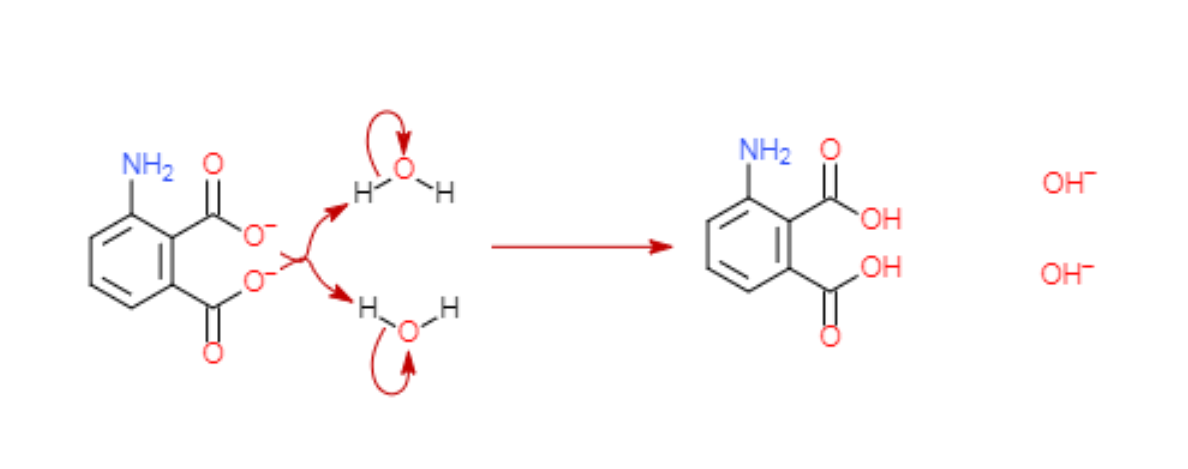

**Figure 7.** Water reacting with 3-aminophthalate to form hydroxide ions

The second part of the graph has the equation y = 0.0227 + 0.0060 / (x-1.4872). I expected the line of best fit to have an equation similar to what I have predicted in the theory portion, as the decrease in enthalpy is caused by the increase in wavelength and thus decrease in energy in the photons emitted. The energy of the photon decreases as the amount of potassium hydroxide increase because more hydroxide ions will bond with the negatively charged oxygen ends instead of water. Therefore, my theory predicts that the results will be inversely proportional.

While the equation is inversely proportional relationship, there is a difference: the x and y-intercepts are not 0.This is because the equation that came up with describes the enthalpy change related to the amount of 3-aminophthalate bonded with water. While the amount of potassium hydroxide used to have a relationship with the amount of 3-aminophthalate bonded with water, this relationship is not direct. This is what caused the x and y-intercepts of this equation to not intersect the origin, and therefore my hypothesis still stands.

Going back to my research question, what is the optimal amount of potassium hydroxide to use to achieve maximum change in enthalpy for the chemiluminescent reaction of luminol? My data suggests that the optimal amount lies around 2 grams of potassium hydroxide for a solution with 0.1 grams of luminol, 1 gram of potassium ferricyanide and 50ml of 3% hydrogen peroxide. With the acknowledgment of the molar mass of these different substances and the molar volume of 3% potassium hydrogen peroxide, we can convert them into moles. (Ptable, 2017; USP technologies, 2019) The relationship of molar mass (M), mass (m) and the number of molecules in moles (N) are shown in the following equation.

(Oklahoma City Community College, 2013)

And the relationship between molar volume (Vm), volume (V) and the number of molecules in moles (N) can be related to this equation.

(University of Texas, 2019)

The solution has 0.076 moles of hydrogen peroxide, 0.00271 moles of potassium ferricyanide, 0.000564 moles of luminol and 0.0356 moles of potassium hydroxide. None of these values show a reasonably strong relationship, This is possible because of the lack of data points, which limits the reliability of the measurement of the maximum point on the graph.

Therefore, the data shows that the maximum enthalpy is achieved when the reacting solution contains 2 grams of potassium hydroxide, 0.1 grams of luminol, 1 gram of potassium ferricyanide and 50ml of 3% hydrogen peroxide. No concrete relationship is suggested however, because of the lack of data gathered. My research question is thus answered: the mass of the amount of potassium to put in a neutral solution should be 20 times the mass of luminol present in that solution given that there is excess potassium ferricyanide to catalyze the reaction.

Table 5

## Limitations and Improvements of Experimental errors

|  |  |  |
| --- | --- | --- |
| Errors | Limitation | Improvement |
| The temperature of the solution (Random Error) | The temperature of the solution had a ±1 degree of uncertainty. I tried to control the temperature by cooling the solution in tap water, but the experiment was performed when there were large fluctuations in room temperature. This affects the results because luminol’s reaction speed is directly related to the temperature of the solution. A solution having a higher temperature will produce a brighter glow. I have performed each trial for different data sets on different days, causing this random error to have less effect on my results. | The temperature can be better controlled by heating the water that is acting as a heat sink to a specific recorded temperature. This way, I can ensure that all the reacting solutions are reacting at very similar temperatures, and thus decreasing the effect of temperature on the reaction speed to minimal. What I can also do is that I can perform the entire experiment on a single day, so that there are minimal natural fluctuations in temperature. While this allows as fine control of temperature as the above method, this method will take significantly less time to perform. |
| Distance from lux meter to reacting solution (Random Error) | The measurement of the distance between lux meter to the reacting solution made my uncertainties significantly more substantial, especially since this value is being squared in the calculations. This may very much be the cause of the random errors present in my experiment: the distance to the lux meter varying slightly. | I should use a more precise distance measuring instrument such as a ruler accurate to millimeters to perform the distance measurement. This decreases the uncertainty present. I should also design an instrument that helps maintain the distance between the lux meter and the solution, such as a spacer, which will help decrease the amount of random error. |
| Amount of potassium hydroxide added (Systematic Error) | Since I had limited time to perform my experiment, I was not able to perform very many trials. This leads me to only being able to plot a minimal range of data points. This limits my exploration, as there may be trends that I am unaware of beyond my current data points. This caused me to generally using slightly more potassium hydroxide than planned. | I would use a larger variety of amount of potassium hydroxide and with smaller increments. This will make my data set more reliable, allow me to see more detail and show me undiscovered trends if there are any. |
| The solution remaining in rubber tubing (Systematic Error) | My experiment involved pouring a solution (solution 2) through a rubber tubbing in order to mix with another solution for the reaction to occur, During this process, some of the solution passing through the rubber tubing would get stuck on the side, and not pass through. This caused less reaction than optimal to have occurred for each trial. | To improve, I should use some distilled water to flush the rubber tubing after each experiment. The flushing would significantly decrease the amount of solution sticking to the sides of the rubber tubing, and allow them to participate in the reaction. Since the solution on the side is just a very small amount, their reaction should be recorded separately, as the time that would take them to react would be negligible compared to the rest of the reaction. |

References

Alina, K., Ali Mosayyebi, & Alexey , K. V. (2016). Tuning the chemiluminescence of a luminol flow using plasmonic nanoparticles. *Nature*, 5.

Bureau International des Poids et Mesures. (2019). *Information for users about the redefinition of the SI.* Paris: Bureau International des Poids et Mesures.

Clark, D. E. (2000). *Peroxides and Peroxide Forming Compounds.* Texas: Texas A&M University.

Felming, D. (2002). *Mechanism*. Retrieved from The Chemiluminescence of Luminol - Declan Felming - University of Bristol: http://www.chm.bris.ac.uk/webprojects2002/fleming/mechanism.htm

Georgia State University. (2016). *photom*. Retrieved from HyperPhysics: astr.gsu.edu/hbase/vision/photom.html

Gross, R. W. (1968). Temperature Dependence of Chemiluminescent Reactions . I. Nitrogen Afterglow. *The Journal of Chemical Physics*, 48.

Hu, Y., Li, G., Zhang, & zhu jun. (2013). A novel luminol-based chemiluminescence method for the determination of amikacin sulfate in serum by using trivalent copper-periodate complex. *Journal of Pharmaceutical Analysis*, 7.

Kuntzleman, T. S., Roher, K., & Schultz, E. (2012). The Chemistry of Lightsticks: Demonstrations To Illustrate Chemical Process. *Journal of Chemical Education*, 89.

Medhi, J. (1992). *Statistical Methods: An Introductory Text.* New Age International.

Murphy, T. (2011). *Maximum Efficiency of White Light.* San Diego: UCSD.

NASA. (2012). National Aeronautics and Space Administration. *Conservation of Energy*, 1.

Oarvez, K., Danish Idrees, Michael, A. M., John, C. A., Faozam, A., Guido, F. v., . . . Hassan, I. M. (2014). *Luminol-Based Chemiluminescent Signals: Clinical and Non-clinical Application and Future Uses.* Aook Buichem Biotechnol.

Oklahoma City Community College. (2013, September). *Stoichiometry Tutorial Finding Molar Mass*. Retrieved from OCCC: http://www.occc.edu/kmbailey/Chem1115Tutorials/Stoichiometry_Molar_Mass.htm

Peter, W., Ralph , E., Jacobson, & Sidney , r. (2000). *The Manual of Photography.* Oxford: Focal Press.

Ptable. (2017). *Periodic Table*. Retrieved from Ptable.

PV EDUCATION. (2016, 7 12). *Energy of Photon*. Retrieved from pveducation.org: https://web.archive.org/web/20160712123152/http://pveducation.org/pvcdrom/2-properties-sunlight/energy-photon

Shinde, G. R., & Narwade, M. L. (2014). Effect of Temperature on Chemiluminescence of Luminol in Aqueous Ethyl Amindes with H2O2 + Metal ions. *IOSR Journal of Applied Chemistry*, 3.

The King of random (Producer). (2018, April 7). Surprising Reaction with Dish Soap and Glowsticks [Video file]. Retrieved from https://www.youtube.com/watch?v=sEiSVfnDKEM

University of Pennsylvania. (2010, july 18). *Paranha*. Retrieved from University of Pennsylvania: https://web.archive.org/web/20100718162251/http://www.seas.upenn.edu/~nanofab/chemicals/Piranha.html

University of Texas. (2019, Febuary 17). *Molar Volume*. Retrieved from Chemistry 301: https://ch301.cm.utexas.edu/section2.php?target=gases/ideal-gas-law/molar-volume.html

USP technologies. (2019). *H2O2 Equivalent Values of Concentration*. Retrieved from USP technologies: http://www.h2o2.com/technical-library/physical-chemical-properties/physical-properties/default.aspx?pid=13&name=Equivalent-Values-of-Concentration

Welsh, E. (2011). Science in School. *What is chemiluminescence?*, 7.